**Analyzing Cybercrime Trends and Developing**

**Mitigation Strategies**

**TEAM MEMBERS**

1. YOGESH RHAJA . S
2. SHIEK VASEER . S
3. RUBAN RAJ .N
4. DINESH KUMAR .B
5. ABIMANI .K

**Data Collection and Pre-processing**

**1. Data Acquisition and Preparation**

**1.Data Collection**:

* + **Internal Data**: Gather data from your own organization's records, including incident reports, network logs, and security alerts.
  + **External Data Sources**: Collect data from external sources such as cybersecurity reports, threat intelligence feeds, law enforcement agencies, and industry organizations.
  + **Publicly Available Data**: Utilize publicly available datasets from sources like government agencies, academic research, or open data repositories.
  + **Dark Web Monitoring**: Consider monitoring the dark web for chatter related to cyber threats and attacks.

1. **Data Preprocessing**:
   * **Data Cleaning**: Remove or correct any inaccuracies, inconsistencies, or missing values in the dataset.
   * **Data Integration**: Combine data from different sources into a unified dataset, ensuring compatibility and consistency.
   * **Data Transformation**: Convert data into a suitable format for analysis. This may involve standardizing date formats, encoding categorical variables, and normalizing numerical data.
   * **Feature Engineering**: Create new features or transform existing ones to extract meaningful insights. For example, you might derive features such as attack frequency, severity scores, or attacker profiles.
   * **Anonymization and Privacy Protection**: Ensure sensitive information is anonymized or encrypted to protect privacy and comply with regulations.
   * **Balancing Class Distribution**: If dealing with imbalanced classes (e.g., rare cybercrime events), employ techniques such as oversampling, under sampling, or synthetic data generation to balance the class distribution.

**3.Exploratory Data Analysis (EDA)**:

* + Conduct exploratory data analysis to gain insights into the dataset's characteristics, distributions, and relationships.
  + Visualize key trends, patterns, and correlations using plots, histograms, heatmaps, and other graphical techniques.

**4.Mitigation Strategy Development**:

* + Based on the insights gained from data analysis, develop proactive mitigation strategies to prevent or mitigate cyber threats.
  + Incorporate recommendations for enhancing cybersecurity measures, improving incident response capabilities, and raising awareness among stakeholders.

**5. Data Modeling**:

* + Select appropriate machine learning or statistical models for analyzing cybercrime trends and predicting future threats.
  + Train and evaluate models using techniques such as cross-validation, hyperparameter tuning, and model selection.
  + Consider employing anomaly detection algorithms for identifying unusual patterns indicative of cyber threats.

1. **Continuous Monitoring and Improvement**:
   * Continuously monitor cybercrime trends and evaluate the effectiveness of mitigation strategies.
   * Adapt and refine strategies based on emerging threats, changing attack patterns, and feedback from incident response activities.

Ex :

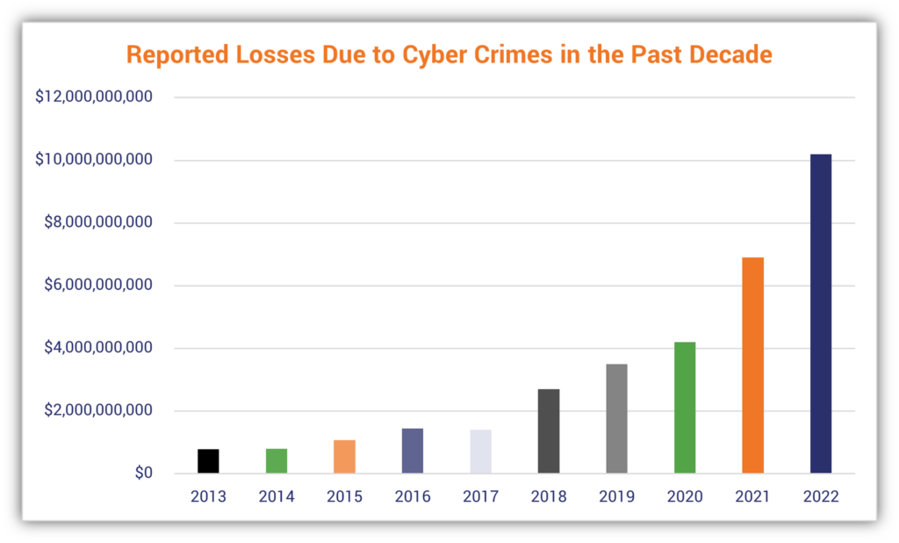

**Insights :**

* Nearly 34% of users in India were targeted by local threats in the year 2023, making the country the 80th most targeted in the world.
* The average cost of a data breach was $4.45 million in 2023, the highest average on record. ([IBM](https://www.ibm.com/reports/data-breach))
* The likelihood that a cybercrime entity is detected and prosecuted in the U.S. is estimated at around 0.05 percent. ([World Economic Forum](https://www.weforum.org/reports/global-risks-report-2022/in-full/chapter-3-digital-dependencies-and-cyber-vulnerabilities#chapter-3-digital-dependencies-and-cyber-vulnerabilities))
* A 2021 LinkedIn data breach exposed the personal information of 700 million users or about 93 percent of all LinkedIn members. ([Restore Privacy](https://restoreprivacy.com/linkedin-data-leak-700-million-users/))
* An attack on Microsoft in March 2021 affected more than 30,000 organizations in the U.S., including businesses and government agencies. ([Microsoft](https://blogs.microsoft.com/on-the-issues/2021/03/02/new-nation-state-cyberattacks/))

